Grade 7 Accelerated · Unit 4 · Lessons 7–8  Real-World Order of Operations  Question Bank 4.07 | Name______________________  Date______________________  Period____________________

Show your work. Circle your final answer.
For questions 1 through 4, substitute and evaluate.
1. 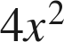 when 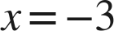

2.  when  and 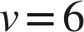

3. 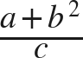 when 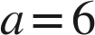, 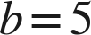, 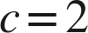

4. 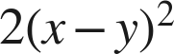 when 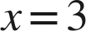 and 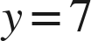

For questions 5 and 6, write and evaluate an expression. Give the unit.
5. A square room of side 11 feet is floored at 3.20 dollars a square foot, with a flat 75 dollars for delivery. Find the total cost.

6. A rectangular deck 14 feet by 9 feet is stained at 1.15 dollars a square foot, with a flat 48 dollars for equipment hire. Find the total cost.

Two formulas.
7. Body mass index is 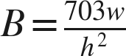, where is a weight in pounds and is a height in inches. Find  to the nearest tenth.
a. , 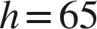

b. , 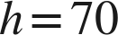

c. , 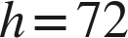

8. Kinetic energy is , for mass in kilograms and speed in meters per second. Find  in joules.
a. , 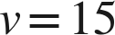

b. , 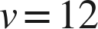

c. , 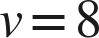

Working backwards.
9. Find the missing value in each situation.
a. 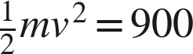 and . Find .

b. 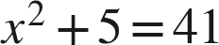, where is positive. Find .

c. A square lawn of side feet is turfed at 2.50 dollars a square foot with a flat 40 dollars delivery, and the total is 2,290 dollars. Find .

Reading the situation.
10. Two problems use the numbers 20, 3 and 5. A: a gym charges 20 dollars to join plus 3 dollars for each of 5 classes. B: a gym charges 20 dollars for each of 3 months, plus 5 dollars to join. Find both totals, and explain why the words 'plus' and 'each' do not decide the operation.

11. A square yard of side 15 feet is turfed at 4.80 dollars a square foot, with a flat 120 dollars for delivery. Which expression gives the total cost?
○ A. 
○ B. 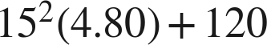
○ C. 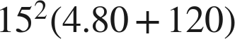
○ D. 

12. Select ALL of the expressions whose value is 45 when .
□ A. 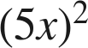
□ B. 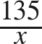
□ C. 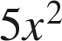
□ D. 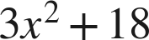
□ E. 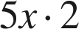
□ F. 